**Assignment 1: Report**

**Nurida Karimbaeva – 7851221**

**The docker image link on dockerhub**

* <https://hub.docker.com/r/nuridak/4350image/tags?page=1&ordering=last_updated>

**Github repo for the source code of your application**

* <https://github.com/nuridak/4350-Assignment>

**Description**

This project is Web Application for exploring Stack Overflow questions. This application is used to find questions from the Stack Overflow by the questions’ *tag value*. The application will process the entered by a user tag and generate two(2) lists of questions; the first list will contain top 10 most recent questions, and the second list will contain top 10 most upvoted questions.

**Logic Description**

The logic behind this application is pretty simple. First thing it does, when it is opened, is waiting for the tag from the user in form of string input. The input will be considered completed only after the Submit button is clicked. After user confirms their inputted tag by pressing Submit button, the *getQuestions()* method will be called. This method retrieves the tag as a variable and uses it to create a HTTP request to the Stack Exchange API server to get the data related to the recent questions that are sorted in descending order by their creation date, and a separate HTTP request to the Stack Exchange API server to get the data related to the recent questions that are sorted in descending order by their votes number. After receiving the data, it retrieves all of the needed values such as title, body of the question, upvote number, creation date, list of answers. After that it calls another method called *Show()* to show all of that information on page. After that the questions are shown on the page.

**Technologies**

* Front-End Language:
  + HTML is used to implement the skeleton design of the application.
  + CSS is used to add some style to the application.
* Back-End Language:
  + JavaScript is used to implement the functionality to the application.
* Databases:
  + Stack Exchange API is used to retrieve the data that is related to the questions from the Stack Overflow.
    - Example: <https://api.stackexchange.com/docs/questions>

**Instructions on how to run the website:**

**Step 1:** open the docker image link provided above

**Step 2:** copy the pull image command and run it in terminal

***docker pull nuridak/4350image:latest***

**Step 3**: run the image through the terminal:

***docker container run --name app -d -p 8080:80 nuridak/4350image***

**Step 4:** open the web page:[***http://localhost:8080***](http://localhost:8080)

**After you are done:** stop and delete (***docker stop app*, *docker rm app***)

**How to enter the tag you want to look up questions:**

**Step1:** after opening the page ([*http://localhost:8080*](http://localhost:8080)*)* you will see the web application

**Step 2:** Enter the tag you want to look for and press Submit button.

* The Refresh button refreshes the page:



**How to explore the questions related to a tag:**

**Step1:** After Submitting an entry you will be able to see Top 10 Most Recent questions, and after scrolling down you will find Top 10 Most Voted questions; and the very bottom you will be able to find the Response Time



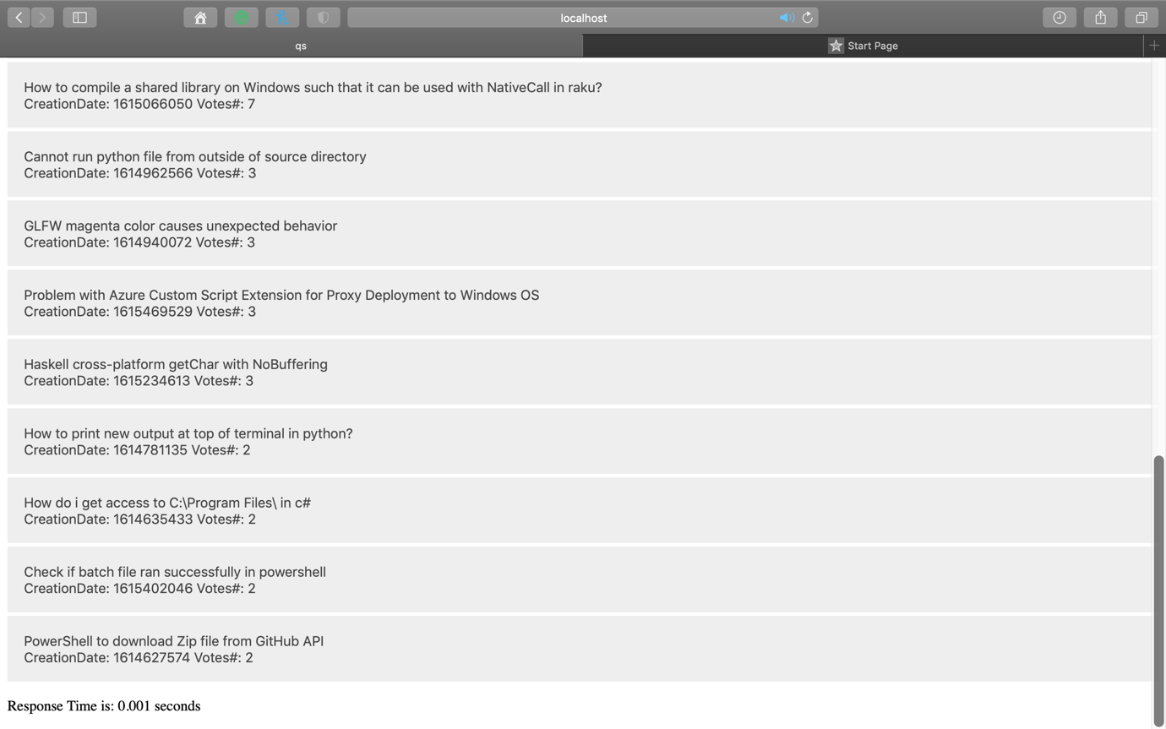

**Step 2:** After Clicking on the title of the question you are interested in, it will be expanded and you will be able to see the question’s details such as question and answers; if the question is not answered it will be mentioned.

